1. **Data Exploration and Cleansing**

**2. What is count of records in the fresh_segments.interest_metrics for each month year value sorted in chronological order (earliest to latest) with the null values appearing first?**

3. **What do you think we should do with these null values in the fresh_segments.interest_metrics?**

Since the percentage of null values is less than 10% we shall drop it

**4. How many interest_id values exist in the fresh_segments.interest_metrics table but not in the fresh_segments.interest_map** **table? What about the other way around?**

**5. Summarise the id values in the fresh_segments.interest_map by its total record count in this table.**

1. **What sort of table join should we perform for our analysis and why? Check your logic by checking the rows where interest_id = 21246 in your joined output and include all columns from fresh_segments.interest_metrics and all columns from fresh_segments.interest_map except from the id column.**

We should use outer join (left join).Because the interest_map consist all the interest_id which is a primary key .

1. **Are there any records in your joined table where the month_year value is before the created_at value from the fresh_segments.interest_map table? Do you think these values are valid and why?**

We have 188 rows where the month_year value is before the created_at value from the fresh_segments.interest_map table. I think these values are valid because months are the same, and the value in the month_year column has the first day of the month but we do not know the real day of the month as we created this column by combining month and year only.

**Interest Analysis**

1. **Which interests have been present in all month_year dates in our dataset?**

1. **Using this same total_months measure - calculate the cumulative percentage of all records starting at 14 months - which total_months value passes the 90% cumulative percentage value?**

1. **If we were to remove all interest_id values which are lower than the total_months value we found in the previous question - how many total data points would we be removing?**

1. **Does this decision make sense to remove these data points from a business perspective? Use an example where there are all 14 months present to a removed interest example for your arguments - think about what it means to have less months present from a segment perspective.**

1. **After removing these interests - how many unique interests are there for each month?**

### Segment Analysis

1. **Using our filtered dataset by removing the interests with less than 6 months worth of data, which are the top 10 and bottom 10 interests which have the largest composition values in any month_year? Only use the maximum composition value for each interest but you must keep the corresponding month_year**

1. **Which 5 interests had the lowest average ranking value?**

1. **Which 5 interests had the largest standard deviation in their percentile_ranking value?**

1. **For the 5 interests found in the previous question - what was minimum and maximum percentile_ranking values for each interest and its corresponding year_month value? Can you describe what is happening for these 5 interests?**

1. **How would you describe our customers in this segment based off their composition and ranking values? What sort of products or services should we show to these customers and what should we avoid?**

The customers in this segment love to travel, some of them are probably business travellers, they prefer luxury lifestyle and go into sports. We should show the products or services related to luxury travel or luxury lifestyle (furniture, cosmetics, apparel), and avoid budget segment or any product or services related to random interests like computer games or astrology. We also can exclude some topics related to locations that are out of area of the customers' interests like Tampa or Oregon, because the customers possibly has already visited those locations and do not wish to return there. Also we can exclude topics related to some long-term needs and the long-term use products, that the customers have probably already purchased. For example, if a customer had an interest in Luxury Furniture or Gym Equipment, they might have purchased those products and do not have interest in this topic anymore.

So in general we need to focus on the interests with high composition value but we need to track this metric to define when customers lose their interest in the topic.

### Index Analysis

**The index_value is a measure which can be used to reverse calculate the average composition for Fresh Segments’ clients.**

**Average composition can be calculated by dividing the composition column by the index_value column rounded to 2 decimal places.**

1. **What is the top 10 interests by the average composition for each month?**

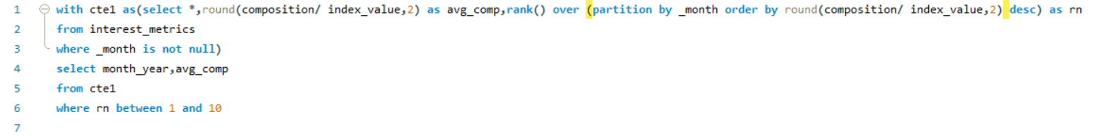

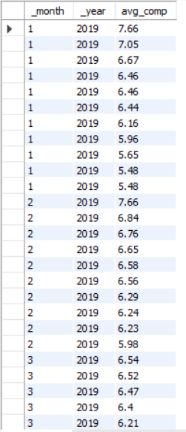

1. **For all these top 10 interests - which interest appears the most often?**

1. **What is the average of the average composition for the top 10 interests for each month?**

